
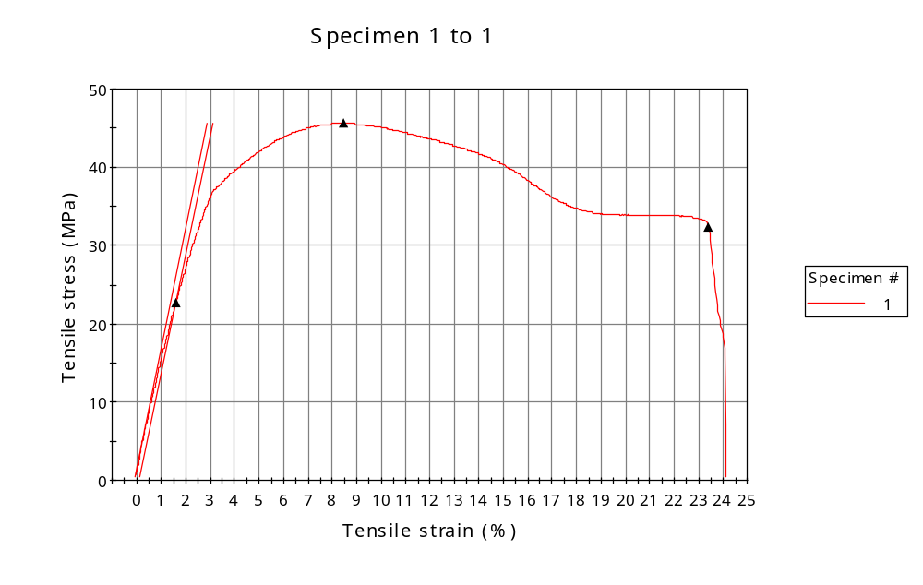
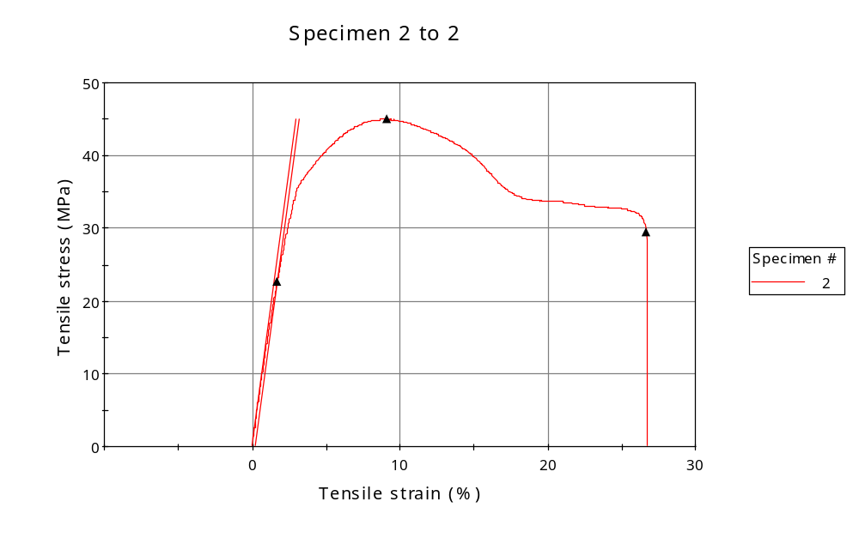
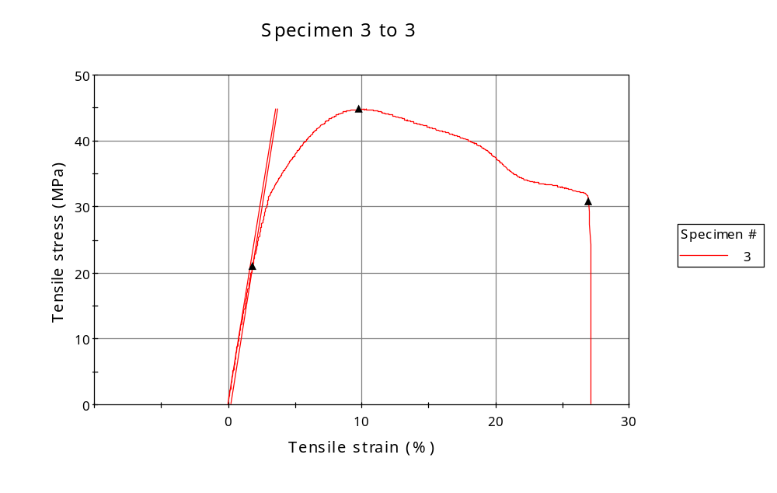
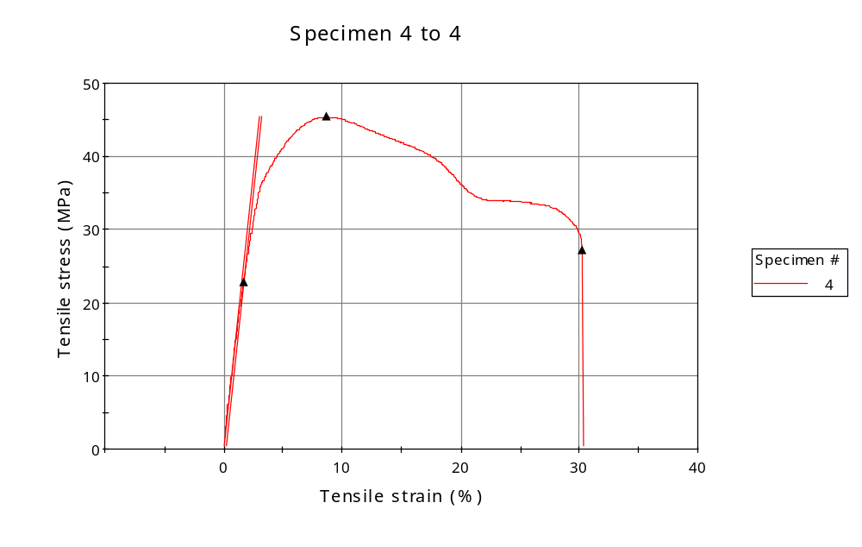
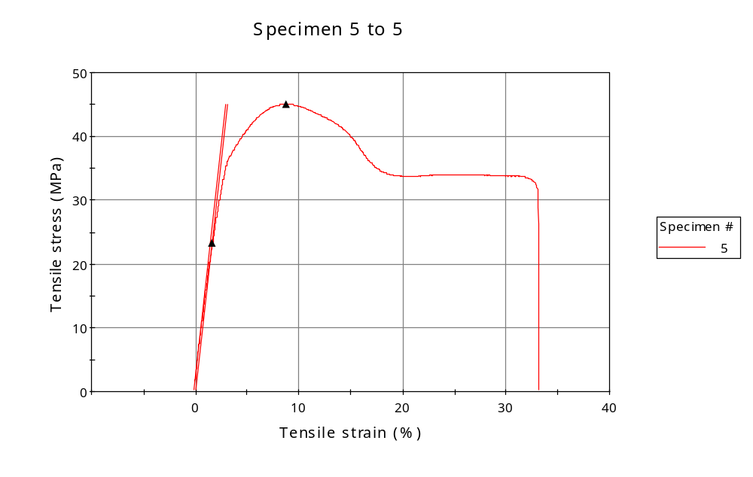
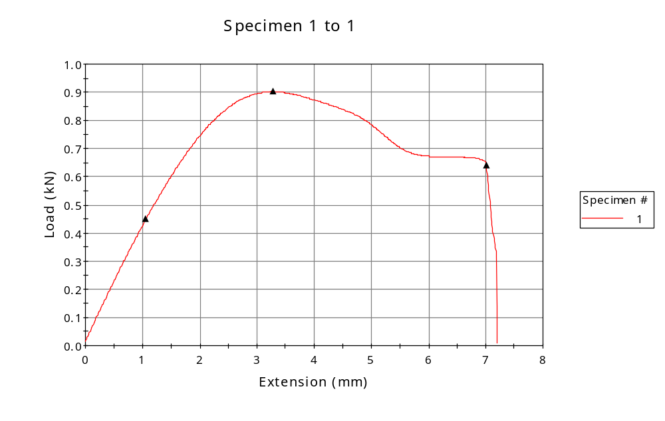
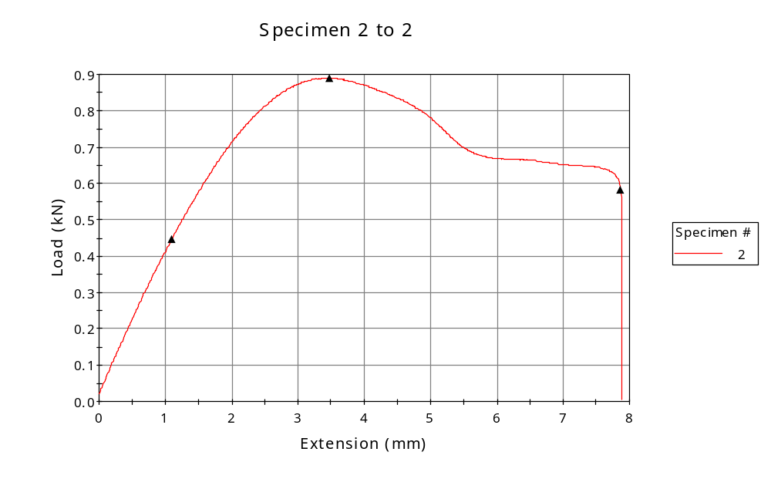
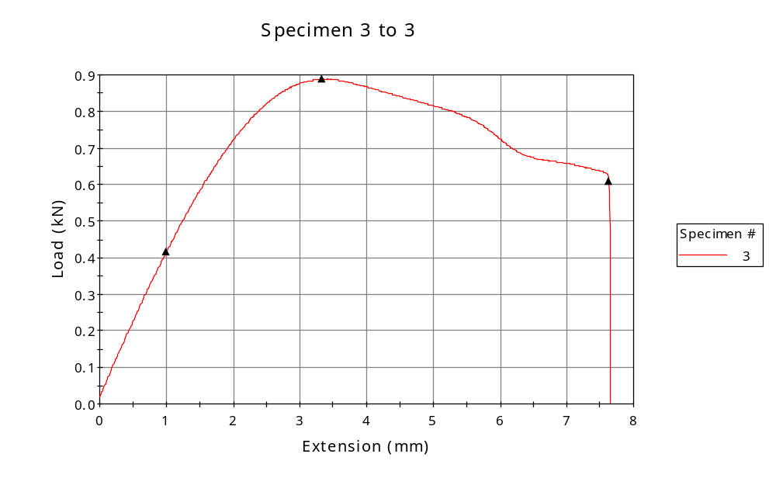
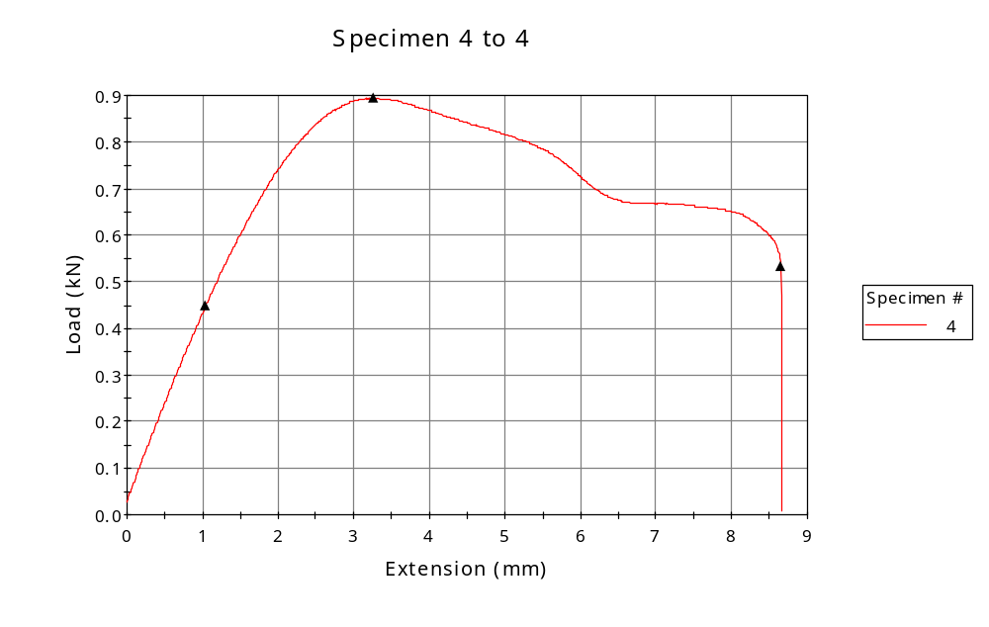
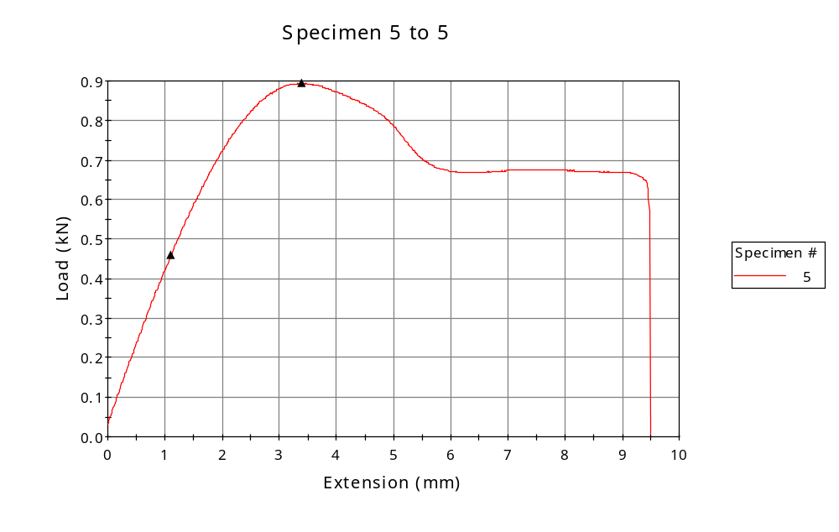

 | CP ID | Length  (mm) | Width  (mm) | Thickness  (mm) | Modulus (Automatic Young's)  (MPa)
1 | CP-FDM_YX2_01 | 25.00 | 5.94 | 3.33 | 1531
2 | CP-FDM_YX2_02 | 25.00 | 5.92 | 3.34 | 1514
3 | CP-FDM_YX2_03 | 25.00 | 5.95 | 3.33 | 1267
4 | CP-FDM_YX2_04 | 25.00 | 5.93 | 3.32 | 1512
5 | CP-FDM_YX2_05 | 25.00 | 5.92 | 3.35 | 1453
Maximum |  | 25.00 | 5.95 | 3.35 | 1531
Minimum |  | 25.00 | 5.92 | 3.32 | 1267

 | Load at Fy ( 0.2 %) - LE  (kN) | Tensao em Fy ( 0.2 %) - LE  (MPa) | Deformacao em Fy ( 0.2 %) - LE  (%) | Forca Max  (kN) | Tensao na Forca Max - LR  (MPa)
1 | 0.449 | 23 | 1.591 | 0.903 | 46
2 | 0.447 | 23 | 1.667 | 0.890 | 45
3 | 0.416 | 21 | 1.826 | 0.888 | 45
4 | 0.449 | 23 | 1.675 | 0.894 | 45
5 | 0.460 | 23 | 1.645 | 0.894 | 45
Maximum | 0.460 | 23 | 1.826 | 0.903 | 46
Minimum | 0.416 | 21 | 1.591 | 0.888 | 45

 | Deformacao na Forca Max - LR  (%) | Forca na Forca na Quebra - LQ  (kN) | Deformacao na Forca na Quebra - LQ  (%) | Final length  (mm) | Final width  (mm)
1 | 8.470 | 0.641 | 23.404 | 119.00 | 6.82
2 | 9.107 | 0.582 | 26.674 | 119.00 | 6.82
3 | 9.746 | 0.610 | 26.979 | 119.00 | 6.82
4 | 8.678 | 0.534 | 30.245 | 119.00 | 6.82
5 | 8.766 | 0.650 | 32.767 | 119.00 | 6.82
Maximum | 9.746 | 0.641 | 30.245 | 119.00 | 6.82
Minimum | 8.470 | 0.534 | 23.404 | 119.00 | 6.82

 | Alongamento
1 | 3.76
2 | 3.76
3 | 3.76
4 | 3.76
5 | 3.76
Maximum | 3.76
Minimum | 3.76

